**Mini Project Report on**



**SMART SURVEILLANCE SYSTEM**



**Submitted in partial fulfillment of the requirement for the award of the degree of**

**BACHELOR OF TECHNOLOGY**

**IN**

**COMPUTER SCIENCE & ENGINEERING**

**Submitted by:**

**Student Name**  **University Roll No.**

**Priyanshi Mathur 2021966**

***Under the Mentorship of***

**Mr. Sanjay Roka**

**Designation**



**Department of Computer Science and Engineering**

**Graphic Era (Deemed to be University)**

**Dehradun, Uttarakhand**

**January-2025**



**CANDIDATE’S DECLARATION**

I hereby certify that the work which is being presented in the project report entitled **“SMART SURVEILLANCE SYSTEM”** in partial fulfillment of the requirements for the award of the Degree of Bachelor of Technology in Computer Science and Engineeringof the Graphic Era (Deemed to be University), Dehradun shall be carried out by the under the mentorship of **Mr. Sanjay Roka**, Department of Computer Science and Engineering, Graphic Era (Deemed to be University), Dehradun.

Name : Priyanshi Mathur

University Roll no : 2021966

**Table of Contents**

|  |  |  |
| --- | --- | --- |
| **Chapter No.** | **Description** | **Page No.** |
| Chapter 1 | Introduction |  |
| Chapter 2 | Literature Survey |  |
| Chapter 3 | Methodology |  |
| Chapter 4 | Result and Discussion |  |
| Chapter 5 | Conclusion and Future Work |  |
|  | References |  |

**Chapter 1**

**Introduction**

**1.1 Introduction:**

With the rapid advancement in technology, the demand for intelligent surveillance systems has increased significantly. Conventional CCTV systems are often limited by their reliance on manual monitoring, leading to delayed responses and missed threats. The Smart CCTV System aims to overcome these challenges by incorporating AI and real-time processing capabilities. This system not only ensures better safety and security but also optimizes resource utilization by minimizing human intervention. This is a python GUI application which can run on any operating system, uses webcam and has number of features. This is a Project built using latest Programming Language and highly evolving Computer Science field which is “Computer Vision”. Which means this project allow computer to watch or in other words it gives vision capability to computers.

**1.2 Problem Statement:**

Traditional CCTV systems suffer from several limitations:

Heavy reliance on human operators for monitoring, leading to fatigue and oversight. Inefficient detection of unusual activities or threats. Limited scalability for large-scale deployment. Inability to adapt to evolving security threats in real-time. These challenges necessitate the development of a smarter, automated surveillance solution.

**1.3 Need of Project:**

**Enhanced Security:** Automated detection of anomalies ensures quick identification and response to potential threats. **Resource Optimization:** Reduces the need for constant manual monitoring. **Scalability:** Adapts to various environments, from small premises to large public space. **Real-Time Analysis:** Enables immediate action, reducing the risk of escalation. **Cost-Effectiveness:** Minimizes long-term operational costs by decreasing the reliance on human resources.

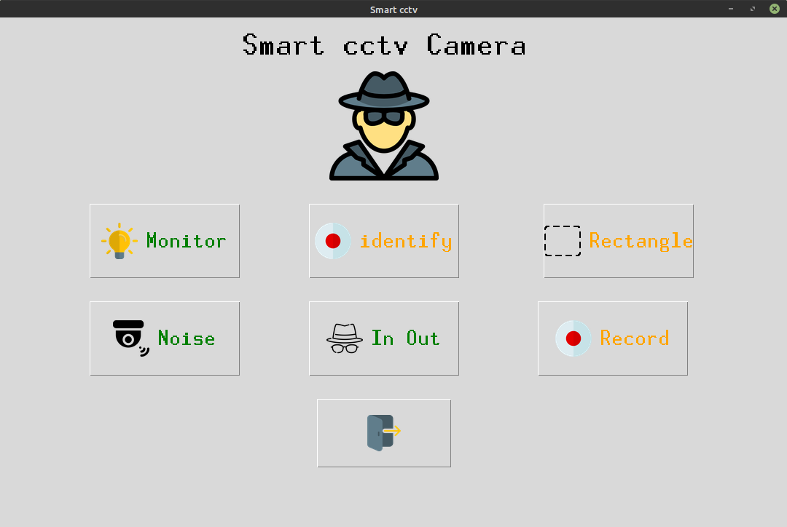

**Fig 1.1 Project Sneak Peak**

**Chapter 2**

**Literature Survey**

**2.1 Literature Survey:**

Several studies have highlighted the potential of integrating AI into surveillance systems. Research on deep learning techniques, such as convolutional neural networks (CNNs), demonstrates their effectiveness in object detection and behavior analysis, which are critical for anomaly detection. Real-time anomaly detection methods, including motion tracking, pattern recognition, and clustering, have shown promising results in identifying unusual activities. Additionally, the use of edge computing for CCTV systems has been explored, enabling real-time processing and reducing latency by performing computations closer to the data source. These advancements underline the transformative potential of AI in modernizing surveillance systems, yet they also reveal gaps in adaptability, scalability, and real-time accuracy, which this project seeks to address.

**2.2 Abstract:**

The Smart CCTV System is an advanced video surveillance solution leveraging Artificial Intelligence (AI) for real-time anomaly detection. The system integrates cutting-edge machine learning algorithms and computer vision techniques to enhance the efficiency, accuracy, and responsiveness of traditional surveillance systems. This project aims to address the limitations of conventional CCTV systems by automating threat detection, reducing human dependency, and ensuring timely response to potential security threats.

**Chapter 3**

**Methodology**

**3.1 Methodology:**

The development of the Smart CCTV System follows a structured approach to ensure effectiveness and reliability. Initially, diverse video datasets representing both normal and anomalous scenarios are acquired for model training and testing. Preprocessing steps, including data cleaning and augmentation, are carried out to enhance model accuracy and robustness. Machine learning and deep learning algorithms, such as YOLO and Faster R-CNN, are employed for object detection, while behavior analysis techniques focus on identifying anomalies. The developed models are then integrated into a real-time surveillance environment using edge computing devices and cloud infrastructure to ensure low-latency operation. Rigorous testing is conducted in various scenarios to validate the system’s performance, followed by incorporating feedback mechanisms to refine and improve the system continuously.

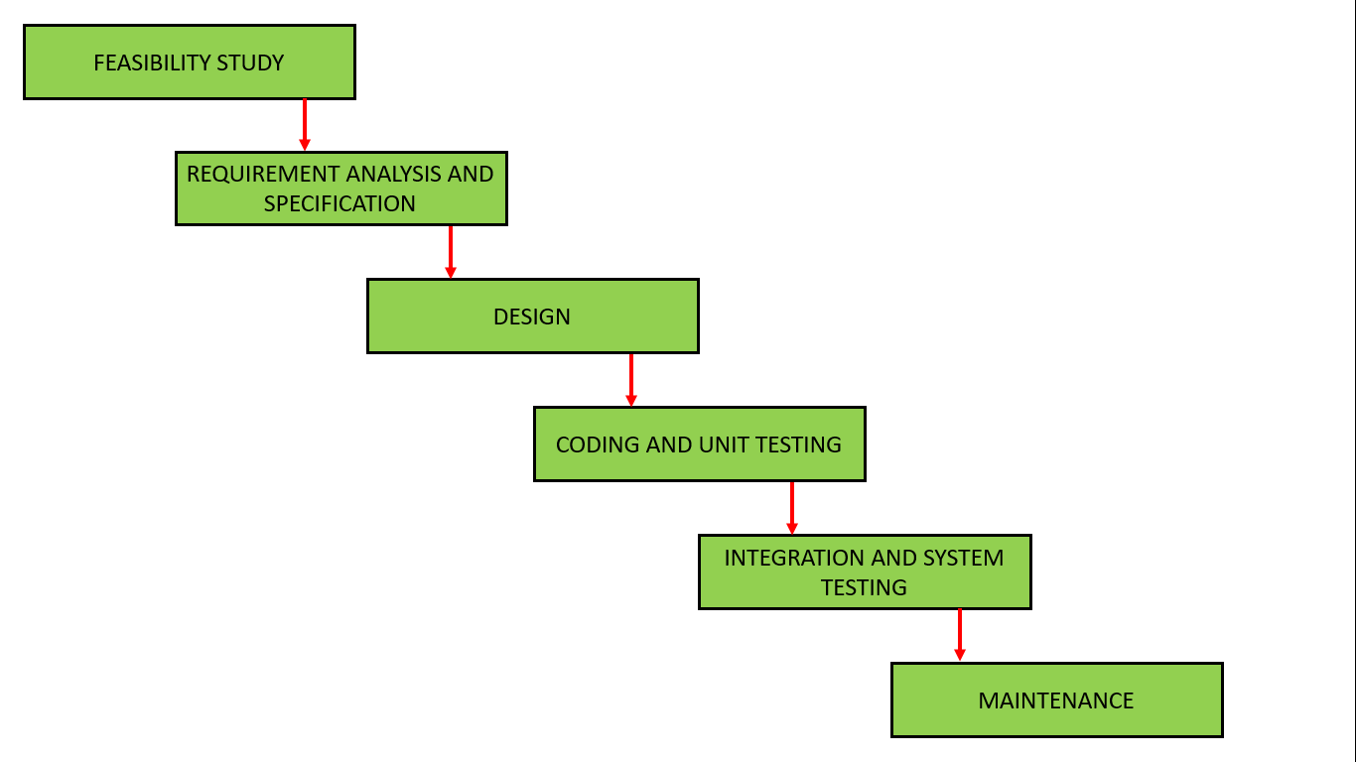

**Chapter 4**

**Result and Discussion**

Below are the different features which can performed by using this minor project:

1. Monitor

2. Identify the family member

3. Detect for Noises

4. Visitors in room detection

Features -

Anti-thief

Noise Detection

Visitors Counting

Normal Recording

Face Identification

It got nice GUI and every button is supported by using beautiful icon.

Monitor – allow to detect what thing is stolen from frame

Identify – Finds the family members (it has to be trained first)

Noise – Finds the motions in the frame

In Out – Finds who entered and Gone from room.The Smart CCTV System was successfully implemented and tested in various scenarios, demonstrating high accuracy in object detection and anomaly identification. The system reduced false positives and enabled real-time threat analysis with minimal latency. Integration with edge computing infrastructure ensured seamless operation, and user feedback highlighted the system's effectiveness in enhancing security measures. These results confirm the potential of AI-powered solutions in transforming traditional surveillance into a proactive security mechanism.

This is working captured output for NO-Motion and Motion being detected by this application.

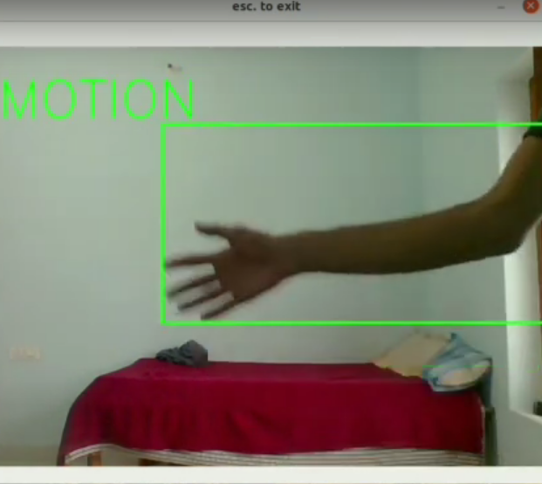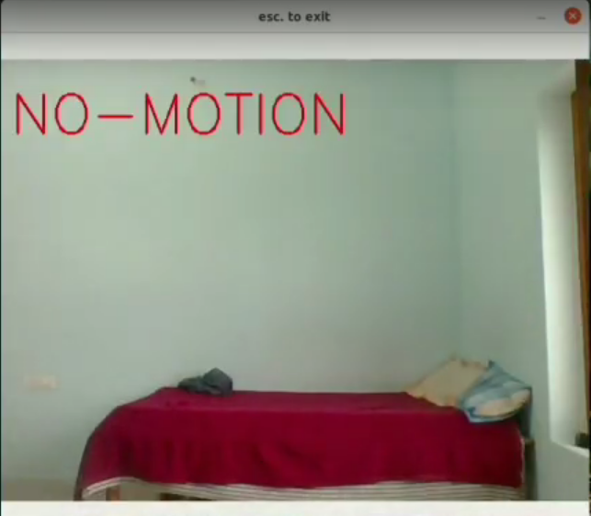

It has detected me entering in the room and being detected as entered and saving the image locally.

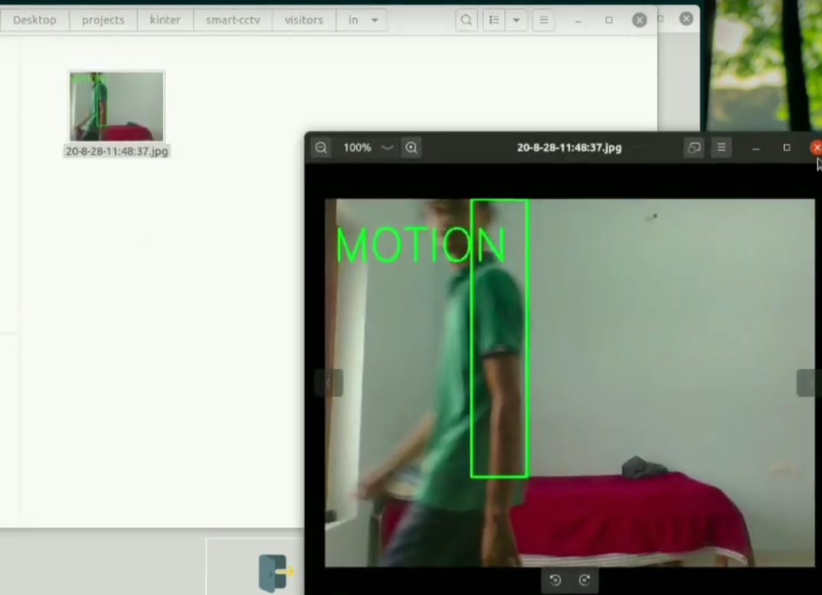

**Chapter 5**

**Conclusion and Future work**

**5.1 Conclusion and Future Work:**

Based On the technology improvements such being having the capability of small size but high processing power this project can be broadly used. Below are some future workout on this project.

* Creating Portable cctv.
* Adding in-built night vision capability.
* Adding deep learning if having high power device.
* More feature such as
  + Deadly weapon detection
  + Accident detection
  + Fire Detection
  + much more.
* Making stand alone application with no requirements such as python, etc.
* Making standalone device.

Adding DL support would create broad scope in this project such as with DL we would be able to add up much more functionality.

**References**

For making this project we have used so many websites and papers and youtube tutorials all are below specified.

* [waterfall model geeksforgeeks](https://www.geeksforgeeks.org/software-engineering-classical-waterfall-model/)
* [Structural Similarity from medium](https://medium.com/srm-mic/all-about-structural-similarity-index-ssim-theory-code-in-pytorch-6551b455541e)
* [face detection](https://medium.com/geeky-bawa/face-identification-using-haar-cascade-classifier-af3468a44814)
* [LBPH algorithm](https://towardsdatascience.com/face-recognition-how-lbph-works-90ec258c3d6b)
* [open CV](https://www.youtube.com/channel/UCx1_WfGX9D9rmsJNBM5qsMA)
* [tech with tim](https://www.youtube.com/channel/UC4JX40jDee_tINbkjycV4Sg)

Also we have used so many other you tube channels and google and stack overflow to solve our errors.

Also we used Official python documentations to know basics about python.